How to Create an Educator Licensure Information System (ELIS) Account

In order to comply with a mandate from the Illinois State Board of Education, students admitted to a professional educator licensure program must create their Educator Licensure Information System (ELIS) account within two weeks of receiving this notification. Once created, send your IEIN (which is created as part of your ELIS account set-up, see Step 8 below), to info@cote.illinois.edu. This is required in order for the Council on Teacher Education to fulfill its part of the State ELIS mandate. Instructions

If you already have an IEIN due to paraprofessional, substitute, or other preexisting licensure with ISBE, do not create a new account. Please send this IEIN to info@cote.illinois.edu.

- Start at https://www.isbe.net/

- Select “Log Into ELIS” (top left-hand corner of the page)

- Select “Login to your ELIS account” (under Educator Access)

- Select “Click Here for First Time Access to the ELIS System” (top right-hand corner of the page)

- Complete the “ELIS for Educators Account Sign Up” form. Fill in all of the required fields on the IWAS – ELIS for Educators Account Sign Up page. Once you have filled in the profile, click “Continue.”

Important tips:
- To assure that your test results are linked to your ELIS account, use your legal first and last name and check to be sure you are using the correct SSN when creating your ELIS account and when registering for any licensure testing.
- Do not use a middle initial when you create your Illinois Licensure Testing System account for content test registration, as this discrepancy will cause your test results to not link to your ELIS account.
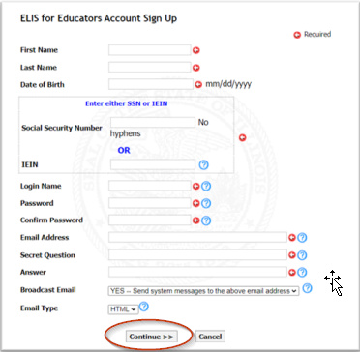

- Verify the information you populated into your profile on the “Account Sign Up Confirmation” screen and click “Submit” if everything is accurate. Choose the “Edit” option if there are errors.

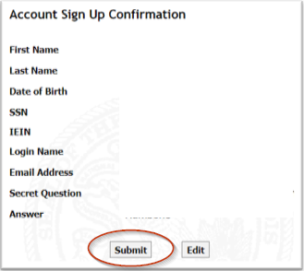

- From the “Congratulations” screen, click “Continue” to go to your ELIS account.

- On the Home Page of your ELIS account, you will find your Illinois Educator Identification Number (IEIN).

Email your IEIN to info@cote.illinois.edu.

0055500

Licensure Application: You will submit your application for licensure through the Council on Teacher Education Student Portal once you have registered for your student teaching/internship. This course is generally completed during the final semester of your licensure program. Do not apply for your license or subsequent endorsement(s) through your ELIS account. If you apply through your ELIS account, you may be charged twice for your license and experience significant delays in licensure processing.

