Practice Content Test Voucher Redemption Instructions

How to register for a practice content test using a voucher
- Visit the “Prepare” page on the ILTS website using the Prepare link on the home page.
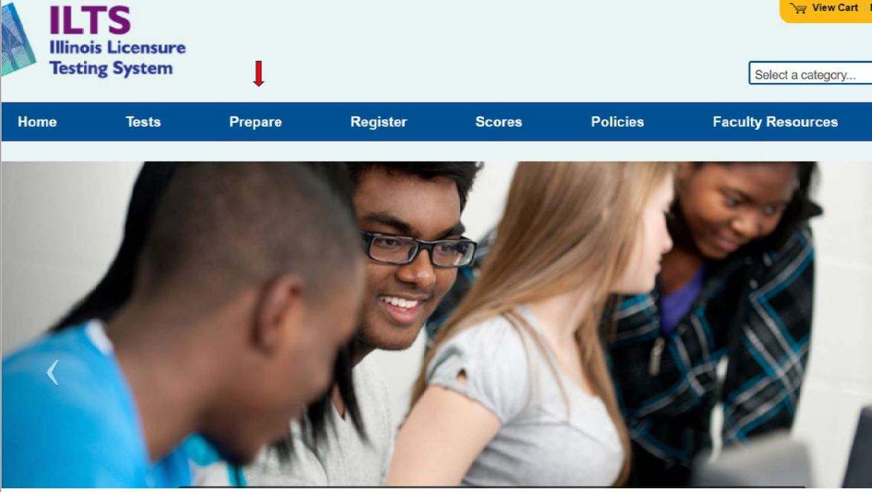
- From the “Prepare” page, select the “ILTS Practice” link from the right-side menu.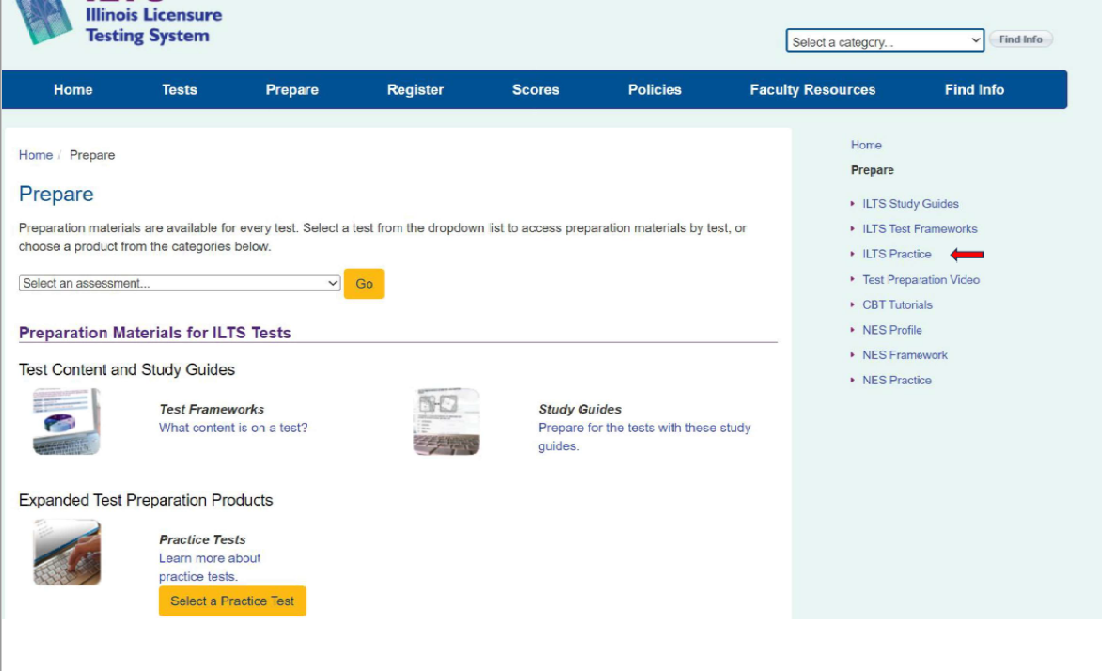

- Choose the appropriate test from the “Select an assessment” dropdown menu and click the “Go” button.
Note: The following practice tests are already available free of charge and do not need a voucher: Early Childhood Education (206), School Social Worker (238), and Gifted Education (312).
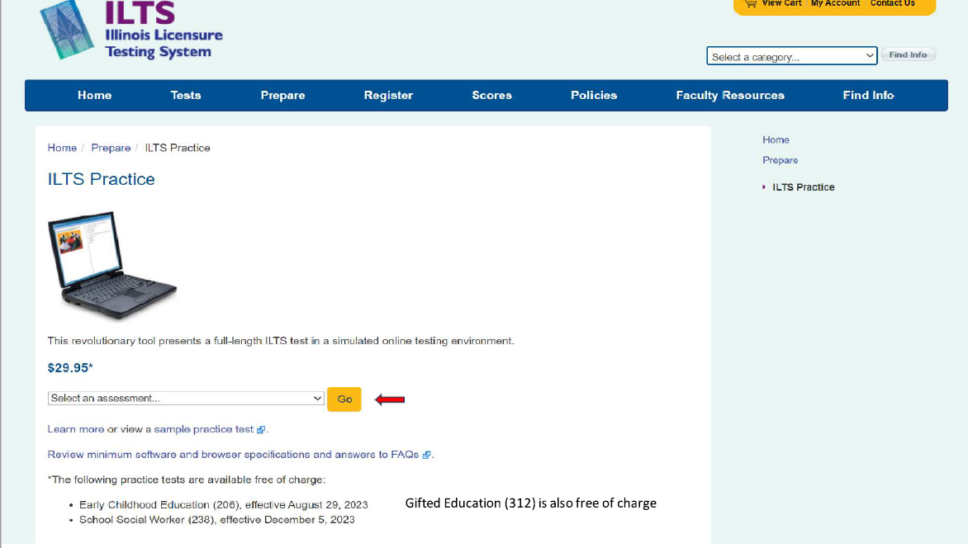
- Select “Buy Now” button at the bottom right of the screen.
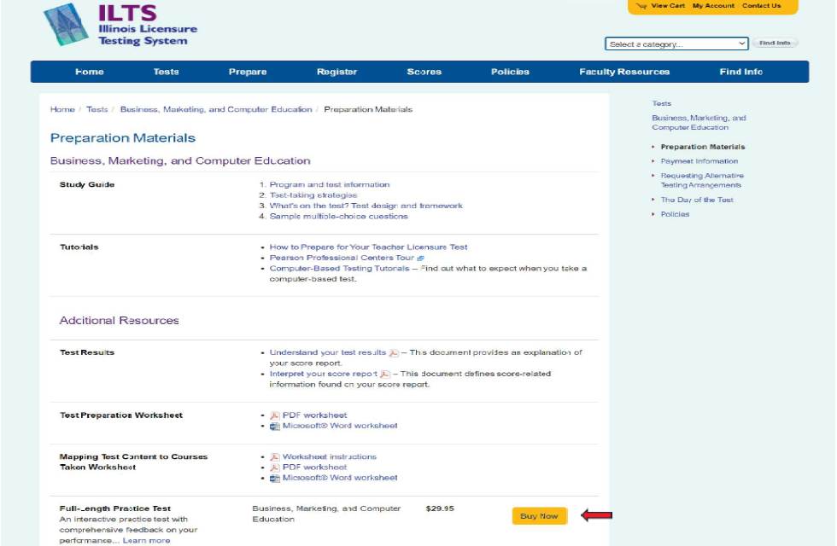

- You will be prompted to create an account. You will also use this account to register for the content test and view your test results. If you already have an account with ILTS, you do not need to create a new one. Simply log in to your existing account.
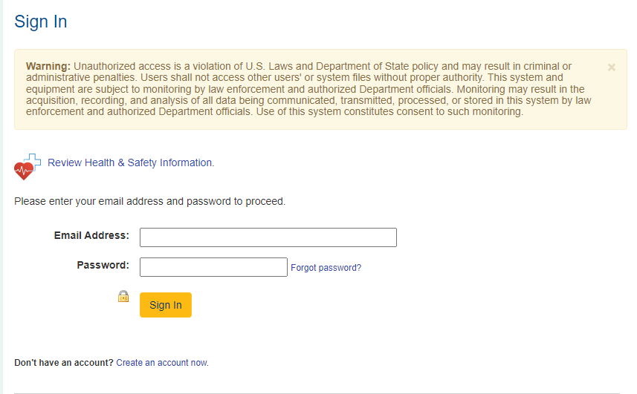

- After creating a new account or logging in to your existing account, you will be taken to the “View Cart” screen. Click the “Check out” button.
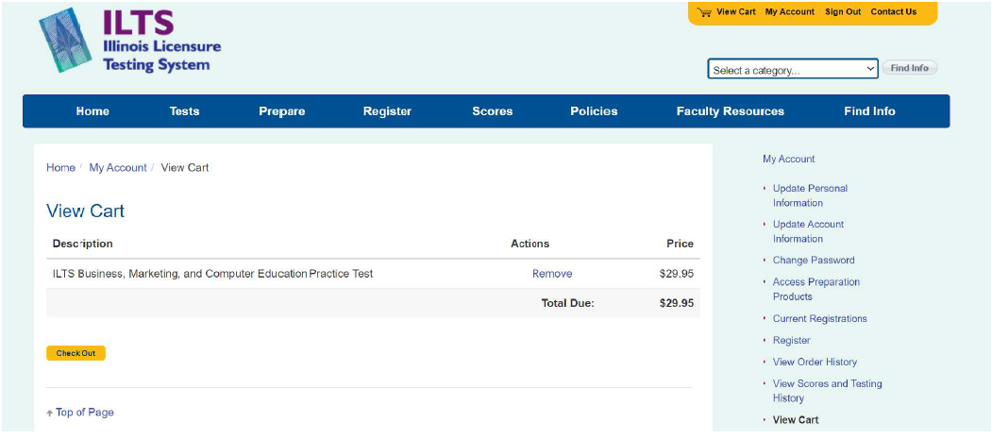
- You will be prompted to enter your billing address.
- After entering it, click the “Next” button.

- You will be taken to the Payment page. On the payment page, click the “Enter a voucher” link.
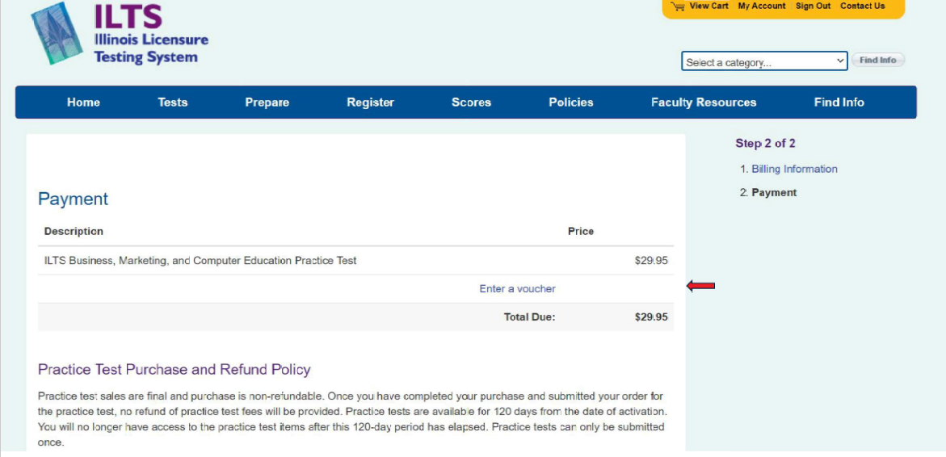
- A text box will appear, and you will enter the voucher code sent to you via email. Click the “Apply” button. After you have applied the voucher, you can complete the purchase.
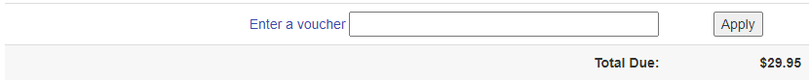

Additional Information

How to get help with purchasing issues
If you have any issues while purchasing the practice test or accessing it after purchase, use the “Contact Us” screen to connect with ILTS customer service.
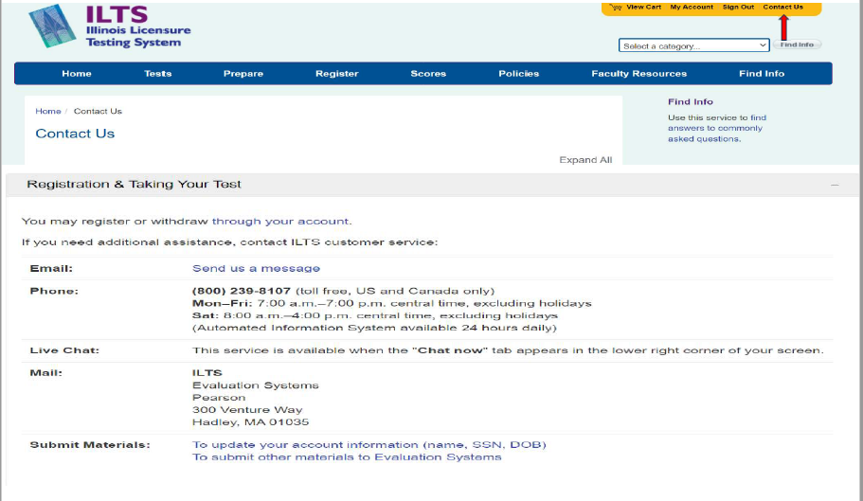

How to get technical assistance
If you need technical assistance from the practice test provider, you can contact Pearson Technical Support.
