October 18, 2023

Sent Via Email

2023-2024 Online Learning Advisory Committee
Sangeetha Gopalakrishan, College of Education, Co-Chair
Eden Haycraft, School of Labor & Employment Relations, Co-Chair
Brian Aldridge, College of Veterinary Medicine
Charlotte Bauer, Graduate College
Scott Cimarusti, Technology Services
Keith Hays, Office for Access and Equity
Frank Hoskinson, The Grainger College of Engineering
Adam King, Gies College of Business
Debra Korte, College of Agricultural, Consumer and Environmental Sciences
Meghan Lea Burnett, College of Media
Gretchen Lohman, University Academic Programs & Services
Tawnya Means, Gies College of Business
Anu Murphy, College of Liberal Arts and Sciences
Adam Rusch, School of Information Sciences
Kristen Sackley, College of Liberal Arts and Sciences
Sara Shrader, College of Applied Health Sciences
Ollie Watts Davis, College of Fine and Applied Arts
Justin York, School of Social Work
Lisa Anderson, Office of Online Learning, ex-officio
Kelly Birky, Center for Innovation in Teaching and Learning, ex-officio
Katie Dalpiaz, Center for Innovation in Teaching and Learning, ex-officio
John Hart, Office of Professional Education, ex-officio
Anna Mehl, Office of the Provost, ex-officio

Dear Colleagues,

Thank you for agreeing to serve as a member of the reconstituted Online Learning Advisory Committee (OLAC). OLAC is a standing committee reporting to the Vice Provost for Undergraduate Education and managed by the Visiting Director of the Office of Online Learning. Eden Haycraft, Director of Graduate Programs in the School of Labor and Employment Relations and Sangeetha Gopalakrishnan, Assistant Dean for Online and Learning Innovation at the College of Education, will co-chair this committee for 2023-2024.
The committee's primary mission remains facilitating constructive discourse among colleges, fostering collaboration to address pertinent issues, and ensuring the continuous improvement of our online courses and programs. Your insights are critical as we navigate the ever-expanding landscape of digital education.
As we embrace the transformative potential of technology-enhanced learning, it has become evident that we need to adapt our committee's structure and purpose to better serve our diverse community.
The rapid advancement of technology, particularly the rise of generative artificial intelligence (A.I.), is reshaping the landscape of online teaching and learning. This trend, along with other changing technologies, challenges us to stay abreast of innovations and consider how they can be harnessed to enhance online education further.
For the 2023-2024 Academic Year, I request that OLAC focus on the following key areas:
- Digital Education Strategy: Offer best practices on policy questions related to online education and its administration across campus.
- Innovation and Technology: Provide feedback on the latest trends and technologies in online education and consider how emerging technologies and innovative teaching methods can be integrated into online learning programs. This includes ensuring online learning initiatives are accessible to all students, including those with disabilities.
- Student Belongingness: Consider how to support online student connectivity and engagement with campus life at the University of Illinois.
The OLAC's role is twofold: it serves as both a platform for the exchange of information and ideas across various campus units and as an advisory body to the university's leadership on matters related to online education. Both functions are important to our success as an institution. The Provost is committed to supporting online education, and your committee plays an important role in realizing our goals. Your OLAC appointments are effective immediately and conclude on June 1, 2024. We wholeheartedly appreciate your dedication to this crucial responsibility.

Sincerely,
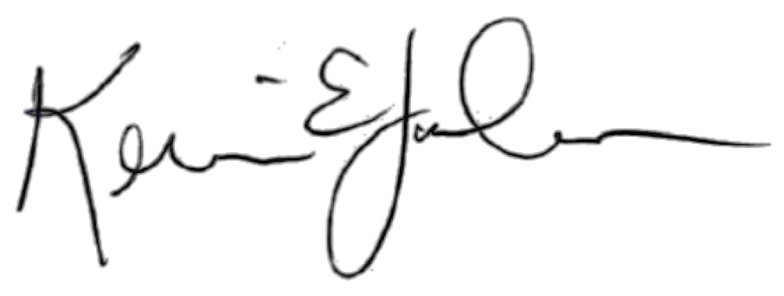

Kevin Jackson
Vice Provost for Undergraduate Education

